TOPIC: SMART TOURIST SAFETY MONITORING AND INCIDENT RESPONSE SYSTEM

MINI PROJECT done by RETHIGA.M from Department of COMPUTER AND COMMUNICATION ENGINEERING

Register no: 922525118044

VSB ENGINEERING COLLEGE KARUR -639 111(AN AUTONOMOUS INSTITUTION)
ANNA UNIVERSITY CHENNAI -600 025

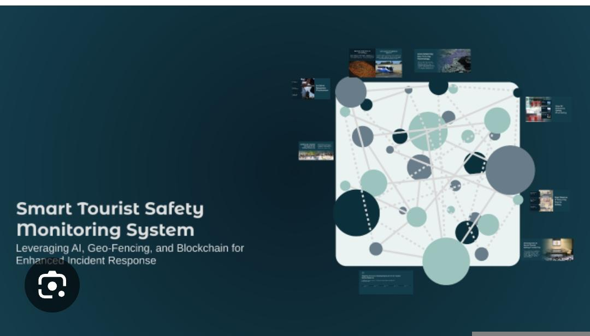
IMPORTANTCE:

*Enhances tourist safety by continuously monitoring tourist locations and activities in real time.

*Provides quick incident detection for accidents, theft, medical emergencies, or unsafe situations.

*Enables faster emergency response through instant alerts to authorities and rescue teams.

*Improves communication between tourists, emergency services, and local authorities.

*Helps reduce crime against tourists by tracking suspicious activities.

*Increases confidence and trust among tourists, encouraging more travel.

*Supports GPS-based location tracking to help locate missing or lost tourists.

*Provides emergency assistance features such as panic buttons and SOS alerts.

*Helps authorities manage crowd control in tourist destinations.

*Enables collection of safety-related data for better planning and decision-making.

USES:

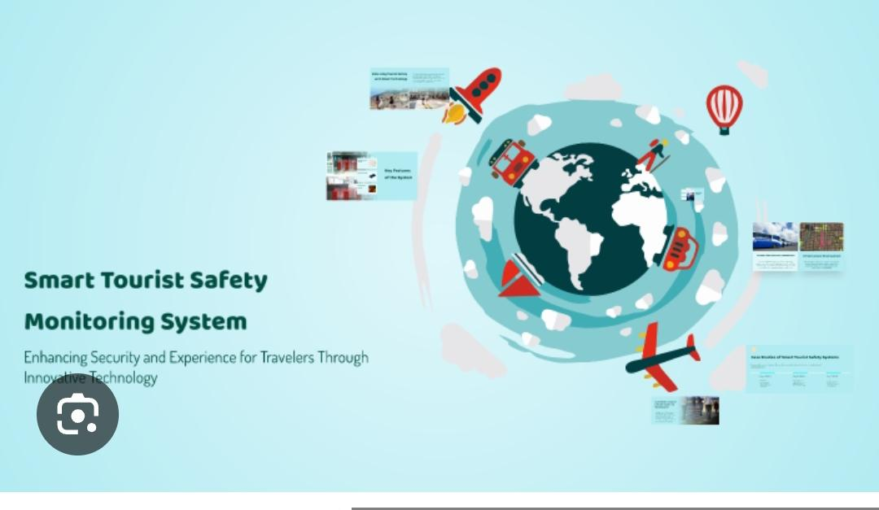
1.Detection of suspicious or criminal activities.

2.Crowd monitoring and management at tourist places.

3. Medical emergency assistance and notification.

4.Disaster warning and evacuation support during floods, earthquakes, or other emergencies.

5.Lost person identification and tracking.
Communication between tourists and emergency services.

6.Safety notifications about risky areas or weather conditions.

7.Collection and analysis of tourist safety data.

8.Monitoring tourist routes and travel patterns.

9.Providing multilingual assistance for international tourists.

10.Improving security management at tourist destinations.

APPLICATIONS:



•Tourist destination safety management.
Real-time tracking of tourists in crowded places.

•Emergency response and rescue operations.

•Smart city tourism management systems.

•Crime prevention and security surveillance.

•Medical emergency support services.

•Disaster management and evacuation systems.

•Airport, railway station, and transport hub monitoring.

•Adventure tourism safety (trekking, hiking, wildlife tours)

•Hotel and resort safety management.

MANUFACTURE OF TOURIST SAFETY CAMERAS:

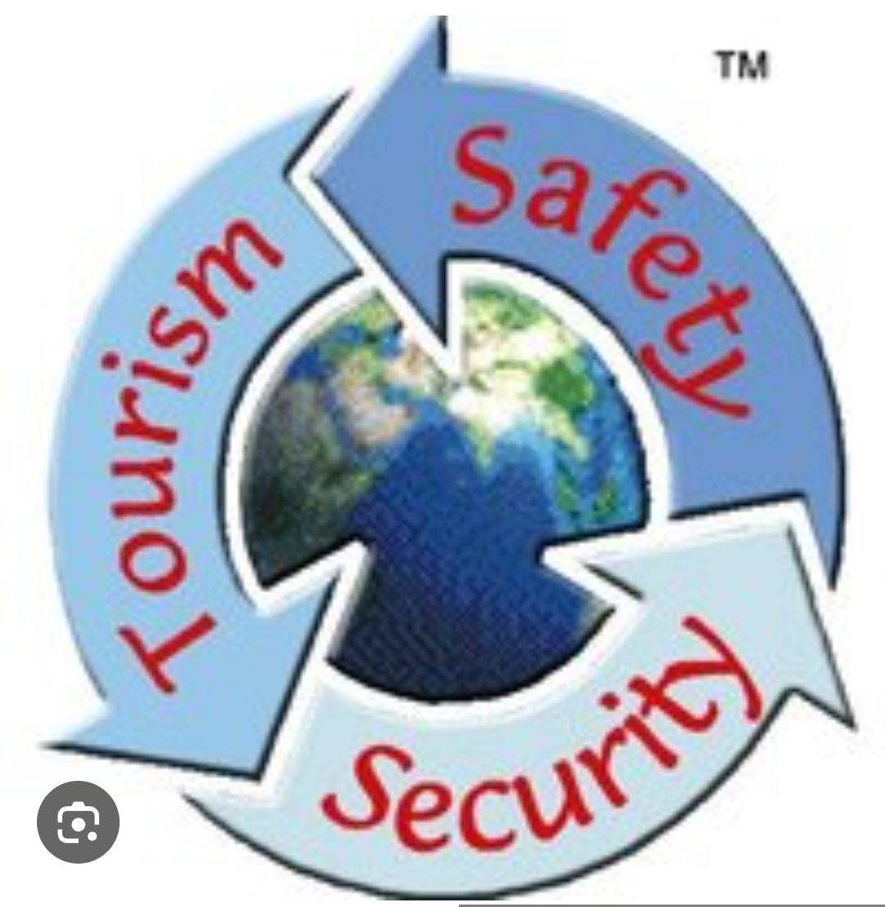
!Define requirements – decide features such as GPS tracking, night vision, emergency SOS, motion detection, live streaming, and incident alerts.

! Design the camera system architecture – create a circuit and system design for the camera and connected modules.

!Select camera components:

*Camera sensor (HD/4K module)
* Lens
* Image processor
* Microcontroller or processor board
Add safety sensors:

!GPS module for location tracking
!Accelerometer and gyroscope for fall detection
!Microphone for audio monitoring
!Motion sensors

Integrate communication modules:

*Wi-Fi
*Bluetooth
*4G/5G or GSM module

Develop emergency features:

1.SOS button
2.Automatic alert system
3. Location sharing system
4.Create software and AI functions:
5.Face recognition
6.Object detection
7. Incident detection algorithms

Design power management:

*Rechargeable battery
*Power-saving circuit
*Charging system

Build the outer casing:

~Lightweight body
~Waterproof and dustproof design
~Shock-resistant materials
~ Assemble all hardware components on the PCB.
~ Install firmware and monitoring software.
~Test the device for image quality, sensor performance, and emergency response.
~Perform quality checks and safety certification.
~ Package the final product and prepare it for deployment in tourist areas.

INCIDENT RESPONSE SYSTEM ESPECIALLY MADE FOR:

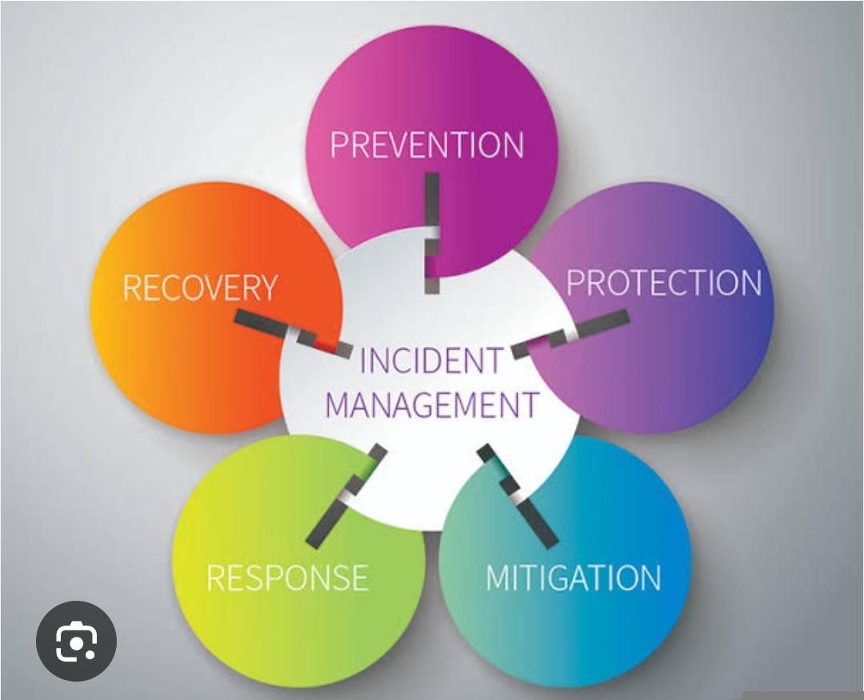

A tourist safety camera is especially made for:

1.Tourists traveling alone.

2.International travelers visiting unfamiliar places.

3.Women travelers for additional safety support.

4.Adventure tourists (trekking, hiking, camping).

5.Senior citizens during travel.

6.Students on educational tours.

7. Pilgrims and religious travelers.

8.Tour guides and travel groups.

9. Families traveling with children.

10.Visitors attending large events and festivals.

11.Wildlife and eco-tourism travelers.

12. Emergency and rescue teams for monitoring tourist areas.

13. Tourism departments and local authorities.

14.Hotels, resorts, and transport services for security purposes

15. Smart city tourism safety management systems.

